SQL Update

🌟 Definition
# Source: AI Source: Provided by: [Data Path: Persons Table -> ID Column: 1, Name_En Column: Motasem Essam] -> From: [ChatGPT] on [6/11/2026]
SQL UPDATE is a statement used to modify existing data in one or more rows of a table.
Unlike INSERT INTO, which adds new rows, UPDATE changes the values of rows that already exist.

🎯 Purpose
# Source: AI Source: Provided by: [Data Path: Persons Table -> ID Column: 1, Name_En Column: Motasem Essam] -> From: [ChatGPT] on [6/11/2026]
UPDATE is used to:
- Change customer information
- Update product prices
- Modify employee salaries
- Correct incorrect data
- Update order status

🧠 Simple Example
# Source: AI Source: Provided by: [Data Path: Persons Table -> ID Column: 1, Name_En Column: Motasem Essam] -> From: [ChatGPT] on [6/11/2026]
Customers Table
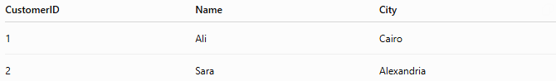
CustomerID | Name | City
1 | Ali | Cairo
2 | Sara | Alexandria

SQL Statement
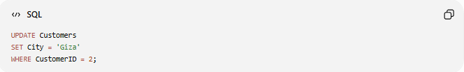
UPDATE Customers
SET City = 'Giza'
WHERE CustomerID = 2;

Result
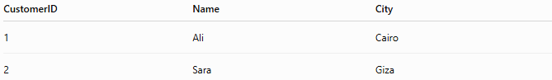
CustomerID | Name | City
1 | Ali | Cairo
2 | Sara | Giza
The city for customer 2 has been updated.

📝 Syntax
# Source: AI Source: Provided by: [Data Path: Persons Table -> ID Column: 1, Name_En Column: Motasem Essam] -> From: [ChatGPT] on [6/11/2026]
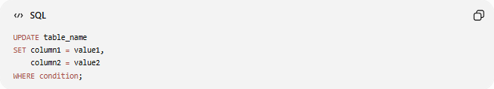
UPDATE table_name
SET column1 = value1,
column2 = value2
WHERE condition;

Syntax Breakdown
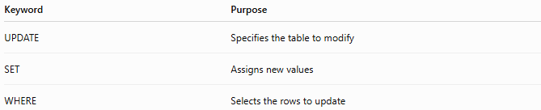
Keyword | Purpose
UPDATE | Specifies the table to modify
SET | Assigns new values
WHERE | Selects the rows to update

📚 Example 1: Update One Column
# Source: AI Source: Provided by: [Data Path: Persons Table -> ID Column: 1, Name_En Column: Motasem Essam] -> From: [ChatGPT] on [6/11/2026]
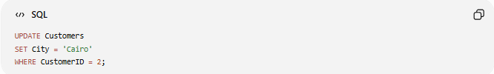
UPDATE Customers
SET City = 'Cairo'
WHERE CustomerID = 2;

Before
CustomerID | Name | City
2 | Sara | Alexandria

After
CustomerID | Name | City
2 | Sara | Cairo

📚 Example 2: Update Multiple Columns
# Source: AI Source: Provided by: [Data Path: Persons Table -> ID Column: 1, Name_En Column: Motasem Essam] -> From: [ChatGPT] on [6/11/2026]
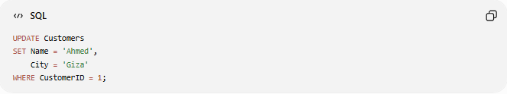
UPDATE Customers
SET Name = 'Ahmed',
City = 'Giza'
WHERE CustomerID = 1;

Result
CustomerID | Name | City
1 | Ahmed | Giza

📚 Example 3: Update Multiple Rows
# Source: AI Source: Provided by: [Data Path: Persons Table -> ID Column: 1, Name_En Column: Motasem Essam] -> From: [ChatGPT] on [6/11/2026]
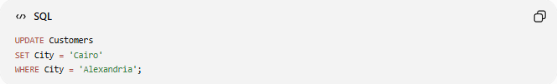
UPDATE Customers
SET City = 'Cairo'
WHERE City = 'Alexandria';

Before
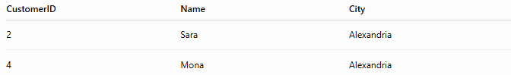
CustomerID | Name | City
2 | Sara | Alexandria
4 | Mona | Alexandria

After
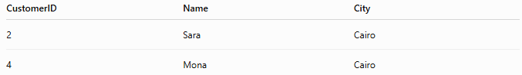
CustomerID | Name | City
2 | Sara | Cairo
4 | Mona | Cairo

📚 Example 4: Update All Rows
# Source: AI Source: Provided by: [Data Path: Persons Table -> ID Column: 1, Name_En Column: Motasem Essam] -> From: [ChatGPT] on [6/11/2026]
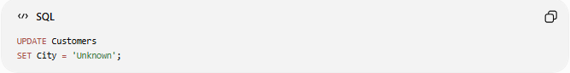
UPDATE Customers
SET City = 'Unknown';

Result
Every row is updated.
⚠️ No WHERE clause means all rows are affected.

⚠️ Importance of WHERE
# Source: AI Source: Provided by: [Data Path: Persons Table -> ID Column: 1, Name_En Column: Motasem Essam] -> From: [ChatGPT] on [6/11/2026]
Safe Update
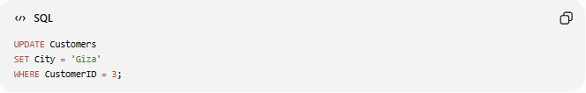
UPDATE Customers
SET City = 'Giza'
WHERE CustomerID = 3;
Only one row changes.

Dangerous Update
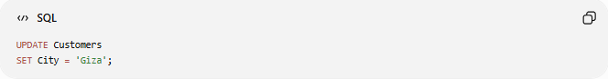
UPDATE Customers
SET City = 'Giza';
All rows change.

📊 Before and After Example
# Source: AI Source: Provided by: [Data Path: Persons Table -> ID Column: 1, Name_En Column: Motasem Essam] -> From: [ChatGPT] on [6/11/2026]
Before
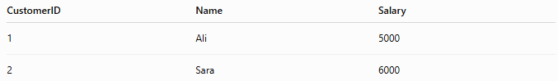
CustomerID | Name | Salary
1 | Ali | 5000
2 | Sara | 6000

Query
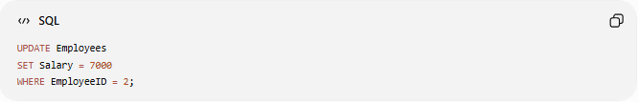
UPDATE Employees
SET Salary = 7000
WHERE EmployeeID = 2;

After
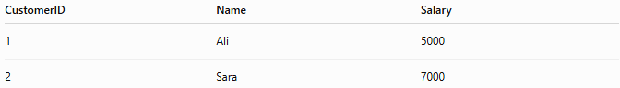
CustomerID | Name | Salary
1 | Ali | 5000
2 | Sara | 7000

📚 Example 5: Update Using Calculations
# Source: AI Source: Provided by: [Data Path: Persons Table -> ID Column: 1, Name_En Column: Motasem Essam] -> From: [ChatGPT] on [6/11/2026]
Increase salaries by 10%.
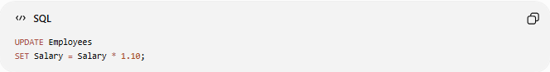
UPDATE Employees
SET Salary = Salary * 1.10;

Before
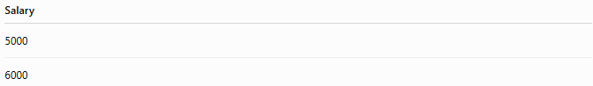
Salary
5000
6000

After
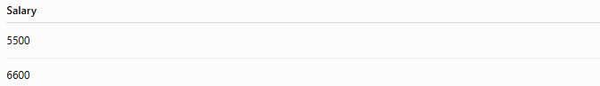
Salary
5500
6600

📚 Example 6: Update with Multiple Conditions
# Source: AI Source: Provided by: [Data Path: Persons Table -> ID Column: 1, Name_En Column: Motasem Essam] -> From: [ChatGPT] on [6/11/2026]
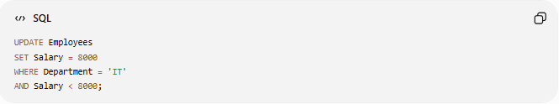
UPDATE Employees
SET Salary = 8000
WHERE Department = 'IT'
AND Salary < 8000;
Only IT employees earning less than 8000 are updated.

📊 Side-by-Side Comparison
# Source: AI Source: Provided by: [Data Path: Persons Table -> ID Column: 1, Name_En Column: Motasem Essam] -> From: [ChatGPT] on [6/11/2026]
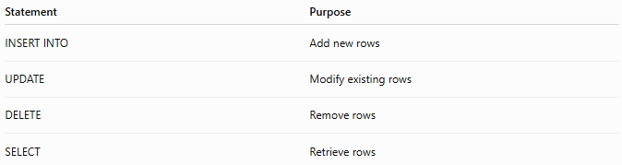
Statement | Purpose
INSERT INTO | Add new rows
UPDATE | Modify existing rows
DELETE | Remove rows
SELECT | Retrieve rows

🛠️ Complete Example
# Source: AI Source: Provided by: [Data Path: Persons Table -> ID Column: 1, Name_En Column: Motasem Essam] -> From: [ChatGPT] on [6/11/2026]
Create Table
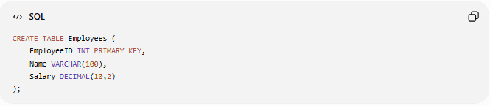
CREATE TABLE Employees (
EmployeeID INT PRIMARY KEY,
Name VARCHAR(100),
Salary DECIMAL(10,2)
);

Insert Data
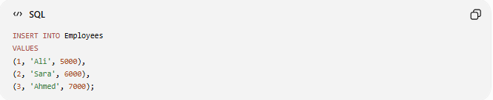
INSERT INTO Employees
VALUES
(1, 'Ali', 5000),
(2, 'Sara', 6000),
(3, 'Ahmed', 7000);

Update Data
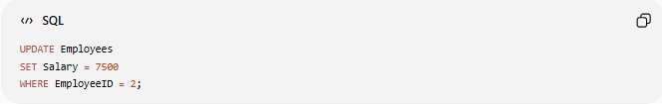
UPDATE Employees
SET Salary = 7500
WHERE EmployeeID = 2;

Check Result
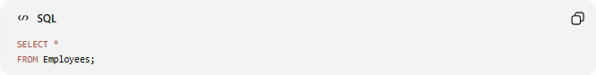
SELECT *
FROM Employees;

Result
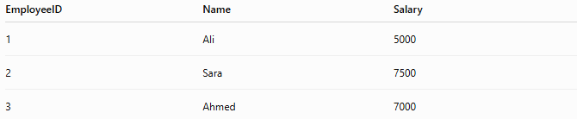
EmployeeID | Name | Salary
1 | Ali | 5000
2 | Sara | 7500
3 | Ahmed | 7000

⚠️ Common Errors
# Source: AI Source: Provided by: [Data Path: Persons Table -> ID Column: 1, Name_En Column: Motasem Essam] -> From: [ChatGPT] on [6/11/2026]
Missing WHERE Clause
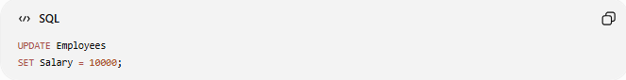
UPDATE Employees
SET Salary = 10000;
Updates every employee.

Wrong Column Name
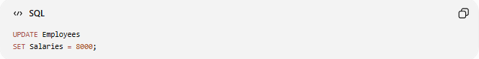
UPDATE Employees
SET Salaries = 8000;
Error if Salaries does not exist.

Wrong Data Type
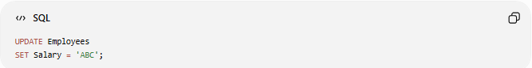
UPDATE Employees
SET Salary = 'ABC';
Error if Salary is a numeric column.

⚖️ Side-by-Side Comparison
# Source: AI Source: Provided by: [Data Path: Persons Table -> ID Column: 1, Name_En Column: Motasem Essam] -> From: [ChatGPT] on [6/11/2026]
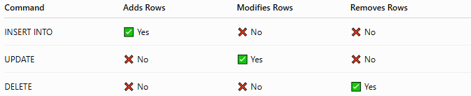
Command | Adds Rows | Modifies Rows | Removes Rows
INSERT INTO | ✅ Yes | ❌ No | ❌ No
UPDATE | ❌ No | ✅ Yes | ❌ No
DELETE | ❌ No | ❌ No | ✅ Yes

🧪 Complete Test Example

1️⃣ Create Table
# Source: AI Source: Provided by: [Data Path: Persons Table -> ID Column: 1, Name_En Column: Motasem Essam] -> From: [ChatGPT] on [6/11/2026]
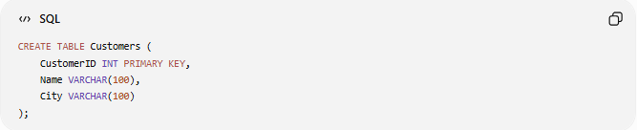
CREATE TABLE Customers (
CustomerID INT PRIMARY KEY,
Name VARCHAR(100),
City VARCHAR(100)
);

2️⃣ Insert Sample Data
# Source: AI Source: Provided by: [Data Path: Persons Table -> ID Column: 1, Name_En Column: Motasem Essam] -> From: [ChatGPT] on [6/11/2026]
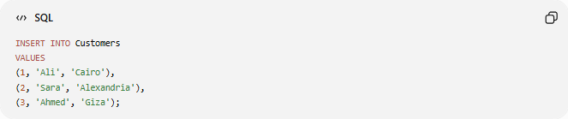
INSERT INTO Customers
VALUES
(1, 'Ali', 'Cairo'),
(2, 'Sara', 'Alexandria'),
(3, 'Ahmed', 'Giza');

3️⃣ View Data
# Source: AI Source: Provided by: [Data Path: Persons Table -> ID Column: 1, Name_En Column: Motasem Essam] -> From: [ChatGPT] on [6/11/2026]
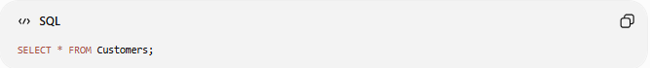
SELECT * FROM Customers;
Result
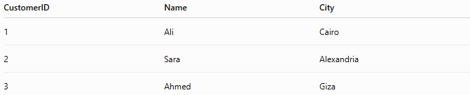
CustomerID | Name | City
1 | Ali | Cairo
2 | Sara | Alexandria
3 | Ahmed | Giza

4️⃣ Update One Record
# Source: AI Source: Provided by: [Data Path: Persons Table -> ID Column: 1, Name_En Column: Motasem Essam] -> From: [ChatGPT] on [6/11/2026]
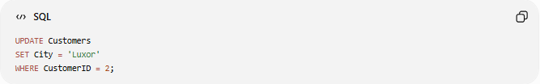
UPDATE Customers
SET City = 'Luxor'
WHERE CustomerID = 2;

5️⃣ View Updated Data
# Source: AI Source: Provided by: [Data Path: Persons Table -> ID Column: 1, Name_En Column: Motasem Essam] -> From: [ChatGPT] on [6/11/2026]
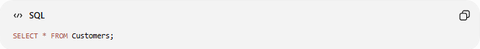
SELECT * FROM Customers;
Result
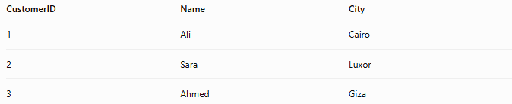
CustomerID | Name | City
1 | Ali | Cairo
2 | Sara | Luxor
3 | Ahmed | Giza

6️⃣ Update Multiple Columns
# Source: AI Source: Provided by: [Data Path: Persons Table -> ID Column: 1, Name_En Column: Motasem Essam] -> From: [ChatGPT] on [6/11/2026]
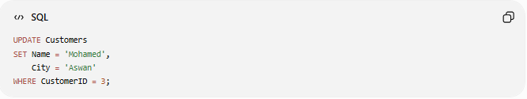
UPDATE Customers
SET Name = 'Mohamed',
City = 'Aswan'
WHERE CustomerID = 3;

7️⃣ Final Result
# Source: AI Source: Provided by: [Data Path: Persons Table -> ID Column: 1, Name_En Column: Motasem Essam] -> From: [ChatGPT] on [6/11/2026]
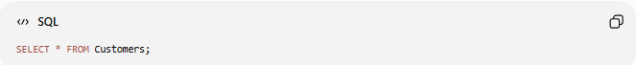
SELECT * FROM Customers;
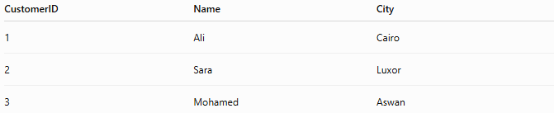
CustomerID | Name | City
1 | Ali | Cairo
2 | Sara | Luxor
3 | Mohamed | Aswan

Real Example

prepared commands

1️⃣ Create Table
# Source: ScreenShot Source: Provided by: [Persons Table -> ID Column: 1, Name_En Column: Motasem Essam] -> Tool: [Automation Table -> ID Column: 16, Name_En Column: Screen Capture] -> From [Operating System: Wampserver64 -> phpmyadmin] on [6/11/2026]
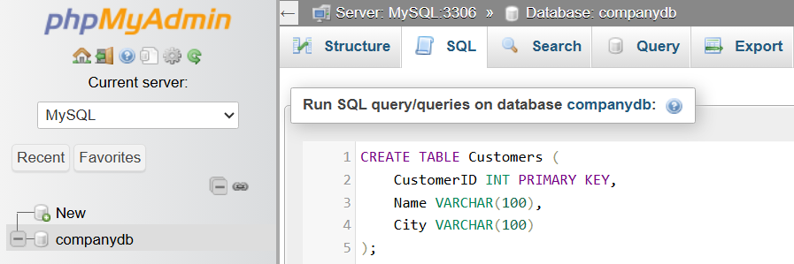
CREATE TABLE Customers (
CustomerID INT PRIMARY KEY,
Name VARCHAR(100),
City VARCHAR(100)
);
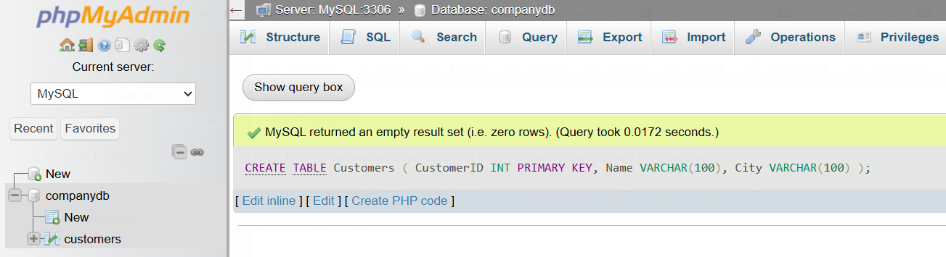

2️⃣ Insert Sample Data
# Source: ScreenShot Source: Provided by: [Persons Table -> ID Column: 1, Name_En Column: Motasem Essam] -> Tool: [Automation Table -> ID Column: 16, Name_En Column: Screen Capture] -> From [Operating System: Wampserver64 -> phpmyadmin] on [6/11/2026]
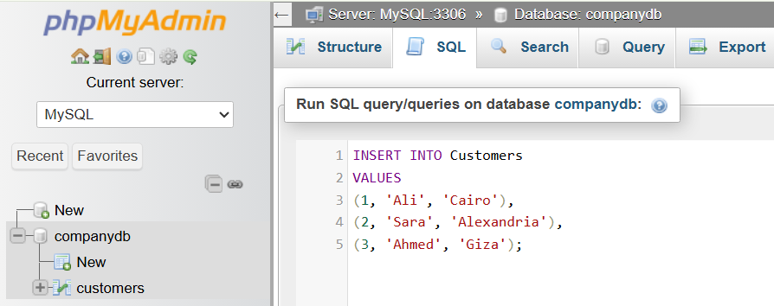
INSERT INTO Customers
VALUES
(1, 'Ali', 'Cairo'),
(2, 'Sara', 'Alexandria'),
(3, 'Ahmed', 'Giza');
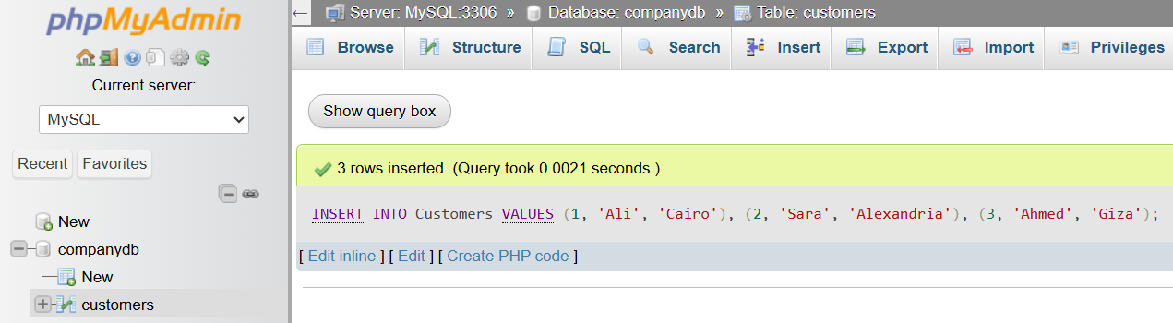

3️⃣ View Data
# Source: ScreenShot Source: Provided by: [Persons Table -> ID Column: 1, Name_En Column: Motasem Essam] -> Tool: [Automation Table -> ID Column: 16, Name_En Column: Screen Capture] -> From [Operating System: Wampserver64 -> phpmyadmin] on [6/11/2026]
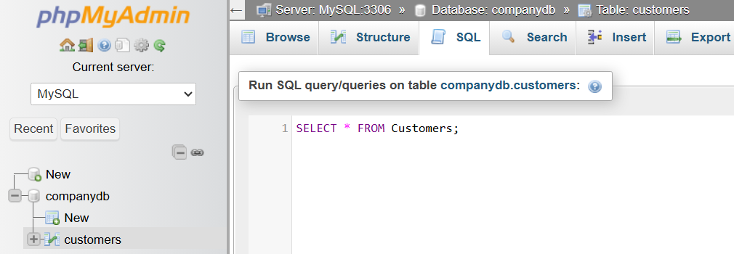
SELECT * FROM Customers;
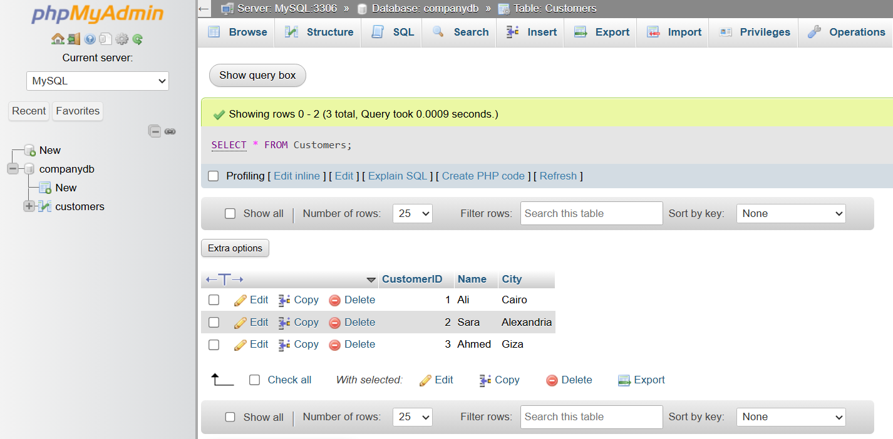

basic command

4️⃣ Update One Record
# Source: ScreenShot Source: Provided by: [Persons Table -> ID Column: 1, Name_En Column: Motasem Essam] -> Tool: [Automation Table -> ID Column: 16, Name_En Column: Screen Capture] -> From [Operating System: Wampserver64 -> phpmyadmin] on [6/11/2026]
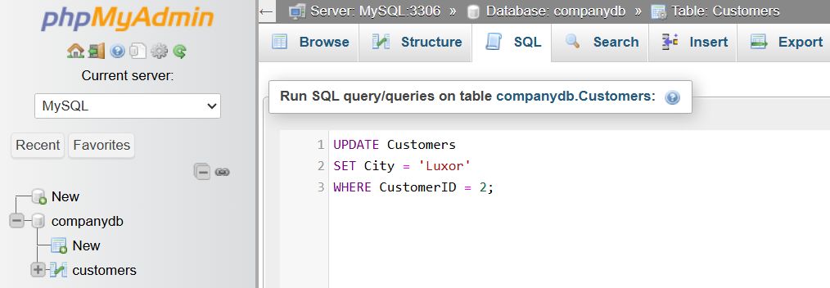
UPDATE Customers
SET City = 'Luxor'
WHERE CustomerID = 2;
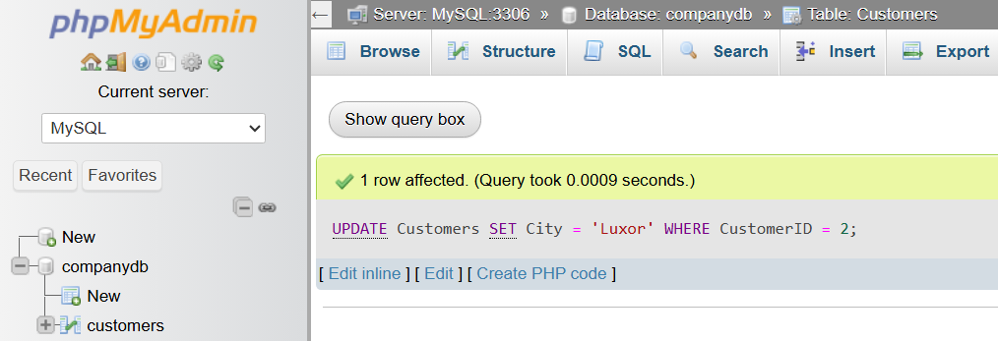

5️⃣ View Updated Data
# Source: ScreenShot Source: Provided by: [Persons Table -> ID Column: 1, Name_En Column: Motasem Essam] -> Tool: [Automation Table -> ID Column: 16, Name_En Column: Screen Capture] -> From [Operating System: Wampserver64 -> phpmyadmin] on [6/11/2026]
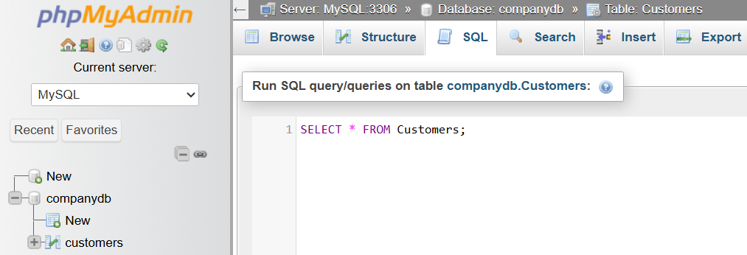
SELECT * FROM Customers;
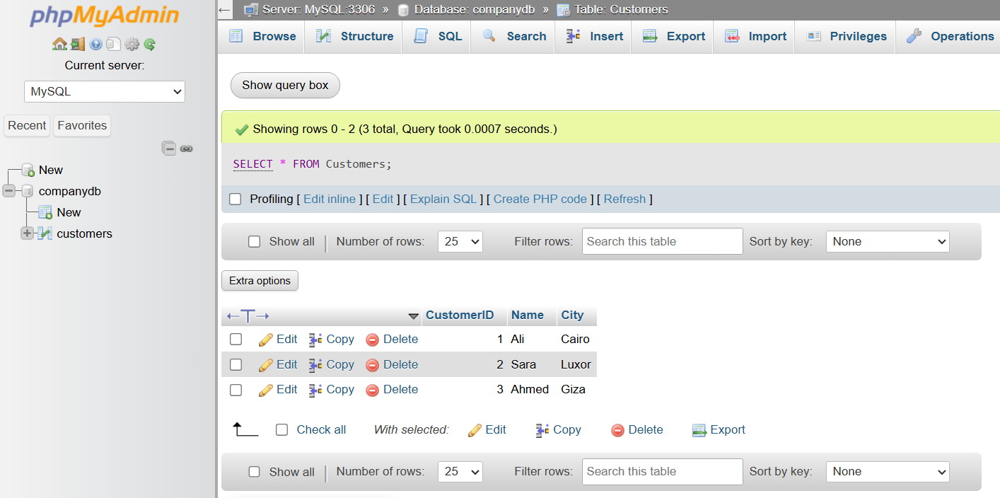

6️⃣ Update Multiple Columns
# Source: ScreenShot Source: Provided by: [Persons Table -> ID Column: 1, Name_En Column: Motasem Essam] -> Tool: [Automation Table -> ID Column: 16, Name_En Column: Screen Capture] -> From [Operating System: Wampserver64 -> phpmyadmin] on [6/11/2026]
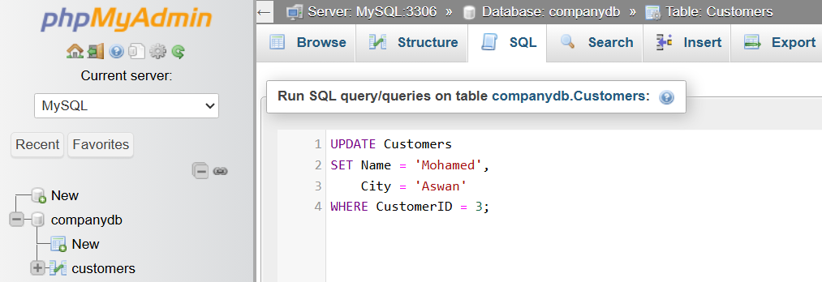
UPDATE Customers
SET Name = 'Mohamed',
City = 'Aswan'
WHERE CustomerID = 3;
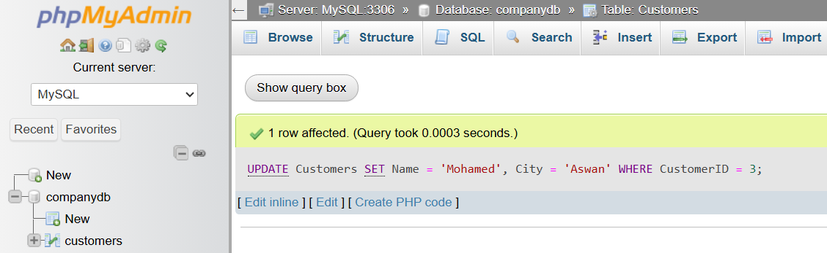

7️⃣ Final Result
# Source: ScreenShot Source: Provided by: [Persons Table -> ID Column: 1, Name_En Column: Motasem Essam] -> Tool: [Automation Table -> ID Column: 16, Name_En Column: Screen Capture] -> From [Operating System: Wampserver64 -> phpmyadmin] on [6/11/2026]
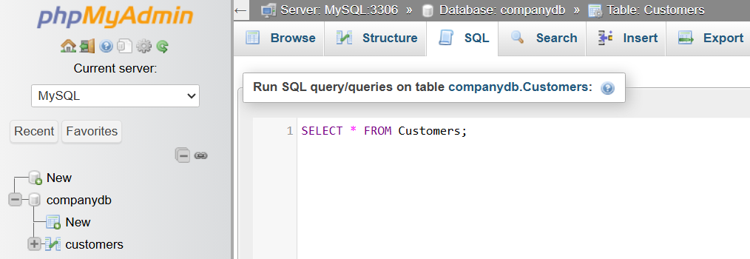
SELECT * FROM Customers;
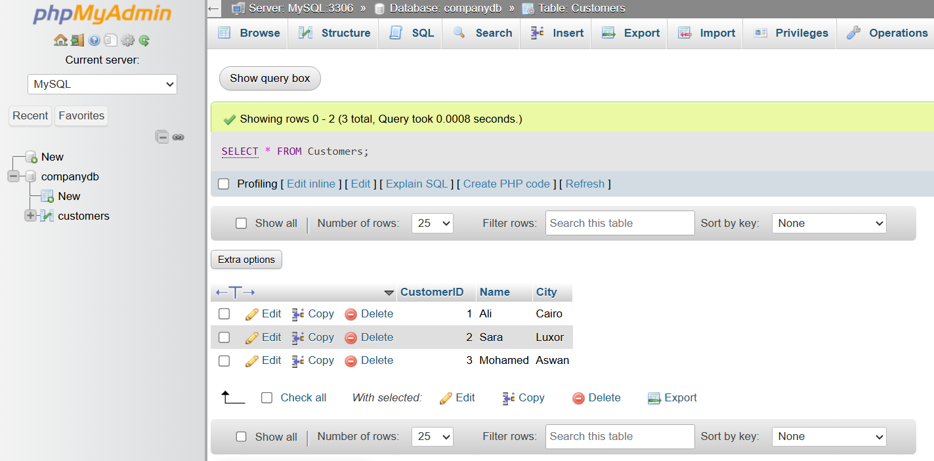

🔢 UPDATE Workflow
# Source: AI Source: Provided by: [Data Path: Persons Table -> ID Column: 1, Name_En Column: Motasem Essam] -> From: [ChatGPT] on [6/11/2026]
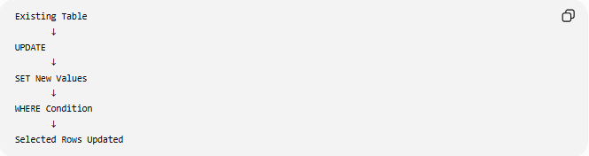
Existing Table
↓
UPDATE
↓
SET New Values
↓
WHERE Condition
↓
Selected Rows Updated

🧠 Simple Analogy
# Source: AI Source: Provided by: [Data Path: Persons Table -> ID Column: 1, Name_En Column: Motasem Essam] -> From: [ChatGPT] on [6/11/2026]
Think of a spreadsheet.
- INSERT INTO adds a new row.
- UPDATE edits an existing row.
- DELETE removes a row.
For example, changing a customer's city from Alexandria to Luxor is an UPDATE operation—you are modifying existing information rather than adding or deleting it.

🧭 Summary
# Source: AI Source: Provided by: [Data Path: Persons Table -> ID Column: 1, Name_En Column: Motasem Essam] -> From: [ChatGPT] on [6/11/2026]
SQL UPDATE is used to modify existing records in a database table. It uses the SET clause to specify new values and the WHERE clause to determine which rows should be updated. Omitting the WHERE clause updates all rows in the table, so it should be used carefully. UPDATE is a core DML (Data Manipulation Language) command for maintaining and correcting stored data.

